Part I: Fossils are clues to the past
What fossils can tell us about ancient life and environments

Dr. Danita Brandt and Dr. Katie Maloney, Department of Earth & Environmental Sciences, Michigan State University

Questions explored: What is a fossil? How do fossils form? What can fossils tell us about how extinct animals lived? What can fossils tell us about ancient environments?
Part I: What is a fossil? 2
Background 2
Activity: Fossil or Not? Coming up with a definition for “fossil” 2
Description 2
Instructions 2
Materials 3
Part II: How do fossils form? 4
Background 4
Activity: Rapid burial (storm-bed-in-a-jar) 4
Description 4
Preparation 4
Instructions 4
Materials 5
Activity: Fossils preserved as molds (imprints) 6
Description 6
Instructions 6
Materials 6
Activity: Fossils preserved as casts 6
Description 6
Instructions 6
Materials: 6
Demonstration: Fossils preserved in amber 6
Background 6
Part III: What can fossils tell us about what animals ate? 8
Background 8
Activity: Examine teeth and try to determine what animal they came from and what the animals ate (mammoth & mastodon in this example) 8
Instructions 8
Materials 8
Part IV: What can fossils tell us about ancient environments? 9
Background 9
Activity: What the Petoskey Stone tells us about how Michigan’s physical environment has changed over millions of years 9
Background 9
Instructions 9
Materials 10
Resources for these activities 11
Materials List 16
General Paleontology Resources 17
Websites 17
Books (classics) 17

Part I: What is a fossil?

Background
The meaning of the word “fossil” has evolved over time. Originally the word referred to any object dug out of the ground (from the Latin fossilis, dug up), which included mineral crystals, but the definition is now narrowed to refer preserved remains and evidence of ancient plants and animals. The fossilized remains of the actual animal or plant are referred to as body fossils.

By examining objects both fossil and not-fossil we will converge on a definition for fossils as the preserved remains of plants and animals.

Activity: Fossil or Not? Coming up with a definition for “fossil”

Description
This activity is divided into three levels:
Level one starts with ‘uncovering’ a basic definition of fossil as the preserved remains of ancient plants and animals (body fossils) by sorting fossil and non-fossil objects.
Level two distinguishes between fossils and artifacts, which are made by humans and studied by archaeologists, not paleontologists.
Level three considers fossil footprints, which are indeed regarded as fossils, but are not the actual remains (body fossil) of a plant or animal and compels us to broaden our definition of ‘fossil’ to include evidence of ancient life.” This activity demonstrates the difficulty in coming up with simple definitions.

Instructions
Level 1: Invite participants to study the objects and separate them into two groups: (1) fossils and (2) not a fossil. Once participants have sorted the objects, the facilitator will lead a discussion of each object. After the group converges on an understanding of which objects are fossils and which are not, the facilitator will lead participants toward a definition for “fossil” as the preserved (fossilized) remains of once-living plants and animals.

Level 2: Is an arrowhead a fossil? Refer to our definition of fossil as “the preserved remains of once-living plants and animals and guide participants through the following questions:
Was an arrowhead a living thing? [no]
What do we call objects made by humans? [artifacts]
What do we call scientists who study artifacts [archaeologists]

Level 3: Query participants about the footprint, as it is not the actual remains of the one-living animal, but a trace made by the animal (footprints, tracks, burrows are referred to as trace fossils).. The recognition of trace fossils requires amending the definition of fossil to include evidence of ancient life. This leads to the distinction of “body fossils” (the actual body parts) and “trace fossils” (footprints, burrows). Artifacts are still excluded from this broad definition of ‘fossil’ as a 'special case' of being objects made by humans.

Materials
(use photos or 3-D printed fossils if needed)
an obviously non-fossiliferous rock, like granite
a mineral crystal, like quartz
arrowhead or stone tool
bone
chicken feather
leaf
modern sea-shell (clam or fresh water mussle)
fossil shell (clam or brachiopod)
fossil leaf
fossil bone
dinosaur footprint
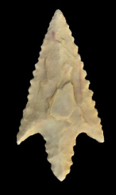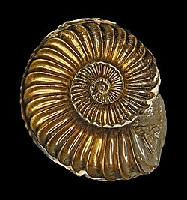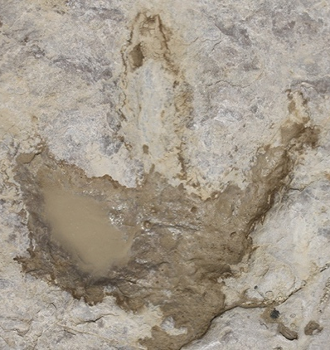

Arrowhead (not a fossil, but an artifact!) Great arrowhead images in 3-D https://stonetoolsmuseum.com/artefact/africa/arrowhead-4/1949/
Ammonite shell—body fossil (Photo from Natural History Museum, London website)
Therapod dinosaur footprint—a trace fossil (Photo from https://www.nhm.ac.uk/discover/dinosaur-footprints.html)

Activity: Rocky the Raccoon explores the Niagara Escarpment

Background
This open-access children’s book is available for free online (https://kidszone.geoscienceinfo.com/). Join Rocky on the Bruce Trail as he searches for a new home along the Niagara Escarpment and meets Lily the crinoid fossil. Together they discover that the rocks of the Niagara Escarpment were formed in a warm shallow sea. Along the way they meet fossil friends and explore how rocks form and change.

The Niagara Escarpment spans from Upper Peninsula of Michigan and northern Wisconsin across southern Ontario and into New York State. A teacher’s guide is also available with printable resources, activities, quizzes and virtual field trips.

Part II: How do fossils form?

Background
Consider the following: Has everything that has ever lived left a fossil? [no]
Fossils are the exception rather than the rule and require special conditions to form (rapid burial), being in the right place at the right time. This activity explores four ways that fossils can form

Activity: Rapid burial (storm-bed-in-a-jar)

Description
Many plants and animals become fossils because they lived in an ocean and were buried rapidly during big storms. The ocean is an environment in which many animals live. It is also an environment subject to large storms, like hurricanes, that can stir up sediment and rapidly re-deposit it. With the “Ocean in a jar” we can see what happens to animals living on the sea floor after a large storm.

Preparation
Prepare the storm-bed-in-a-jar. Fill a plastic jar with tight-fitting lid (an empty peanut butter jar works well) 1/3 full with clean sand and fill the jar with water. Place two or three small modern clam shells on the top of the “sea floor”). Note: you need enough sand to bury the shells after the ‘storm’.

Instructions
Explain to participants that the jar represents a very small ocean with clams living on the bottom, until one day a large storm comes up—the kind of storm we get on the gulf and Atlantic coast at certain times of the year.
[What do we call these storms? [hurricanes].

Shake the jar vigorously to simulate a hurricane.
Your narrative continues:

The hurricane comes along and picks up everything in its path—the sand and everything on in in the sand gets all mixed together, thrown up into the water. After the storm passes, the sand and everything settles out….and we see….no clams! [If the clams are still visible you need to shake it more or go back to step one and add more sand.

Q: What happened to the clams? Did they get washed away? Broken to bits???? [they got buried]

Let’s test the hypothesis that they got buried by using our special clam-excavation-tool (a fork). [Dig the clams out of the sand and confirm that they are still intact. This is how many animals become fossils. The key is getting buried rapidly.

For discussion: Consider, in contrast, an animal that dies in the forest (deer, rabbit). What happens to it? [scavenged, decomposed]. It has little chance of becoming a fossil.

Materials
Clean plastic peanut butter jar or other similarly sized plastic jar with tight-fitting lid.
Enough clean sand to fill the jar about 1/3 full
Two-three smallish clam shells
Water
Plastic fork—the probe/collecting tool
Paper towels.

Photo: storm-bed-in-a-jar set up. Wash the sand before putting in the jar for a cleaner ‘ocean’!

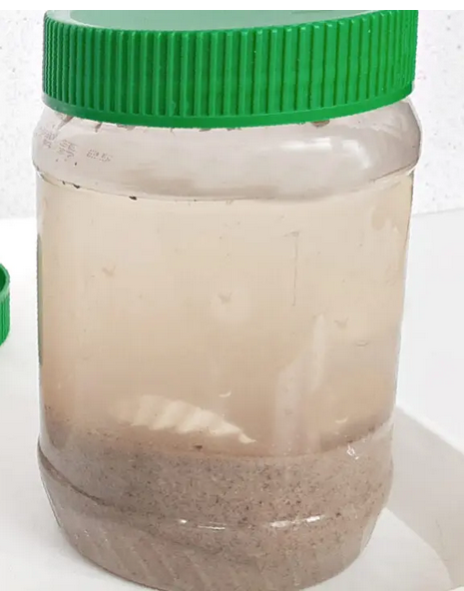

Activity: Fossils preserved as molds (imprints)

Description
Another way a living thing can become a fossil is if it falls into soft mud and leaves an impression that later hardens. We call these imprints or molds. The actual bone or shell is not preserved. This is the same process in which dinosaur footprints are formed.

Instructions
Distribute paper plates; have participants write their name on it. Give each participant a lump of clay and invited them to work it to soften and flatten it (to about a half-inch thick). They can chose the shells they would like to press into the clay to form imprints.

Materials
self-hardening (air-dry) clay,
small paper plates
variety of sea shells

Activity: Fossils preserved as casts

Description
If an imprint were to become filled with mud and the mud hardens, that could create a replica or cast of the animal that made the imprint. In both molds and casts the original “body fossil” is not preserved, but both molds and casts are still considered fossils because they were are made by living organisms.

Instructions
Mix the plaster in small batches. Spray the clay molds with cooking oil and pour the plaster over the molds to fill. Set plates aside to set (casts will be ready to take home the following day).

Materials:
“fossil” imprints created earlier
plaster of Paris
water
mixing bowl and stick
cooking spray.

Demonstration: Fossils preserved in amber

Background
Thanks largely to Michael Crichton and Jurassic Park, many people are aware of insects fossilized in amber. There are ‘recipes’ for making edible ‘amber’ (corn syrup-based candy) and sometimes you find edible insects in ‘amber’ in novelty shops. We do not advocate buying real amber for this demonstration as it is difficult to know the provenance (and thus legality) of this controlled substance.

However, there are many fascinating discoveries of animals—not just insects—preserved in amber and questions of the sort, what are the oldest fossils in amber, where are amber fossils found, etc. that might prompt patrons to learn more. We list some reputable websites in the “Resources” section, below.

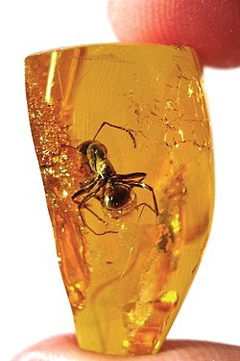
Ant preserved in amber. Photo from Wikipedia article on amber.
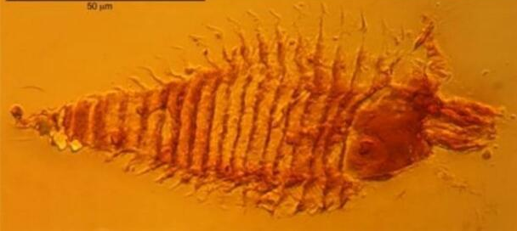
Oldest (to date) fossil in amber. 230 million-year old mite. Much enlarged. From https://www.amnh.org/explore/news-blogs/amber-arthropods-discovery

Part III: What can fossils tell us about what animals ate?

Background
By studying teeth we can tell how large an animal is and what the animals ate. We can use that information about diet to infer the environment they lived in (grassland? Forest?).

Activity: Examine teeth and try to determine what animal they came from and what the animals ate (mammoth & mastodon in this example)

Instructions
With no initial prompting, show participants a mastodon and a mammoth molar (or photos of the molars printed to actual size) and encourage them to speculate on what these objects are and what animals they came from (large? Small? Plant eater? Meat eater? The same kind of animal?).

Once the objects are identified as single teeth (molars) invite participants to compare the size of the molars to their own (a single molar is larger than most people’s head!). Encourage participants to use this information to refine their speculation about the size (and identity) of the animal the molar came from.

Are the two molars the same? How are they similar and different? Invite participants to describe the differences between the two molars. Do you think both came from the same kind of animal?

Explain that the molar with the flat surface is typical of plant-eaters that eat grass. Grass is tough and the flat molars are used to grind the grass. This molar is from a mammoth, so we can infer that mammoths were grazers and lived in open grasslands. [At this point share the artistic reconstruction of a mammoth in its habitat]

The molar with the prominent ‘bumps’ (cusps) are used for shearing soft vegetation like leaves. This molar is from a mastodon, so we can infer that mastodons lived in more brushy, forested environments.

Materials
Mammoth molar (cast or photo; see Resources)
Mastodon molar (cast or photo)
Image of mammoths grazing in grasslands (see Resources)
Image of mastodon in its more forested habitat (see Resources)
Drawing paper
Drawing tools (pencils, markers, etc.)

Part IV: What can fossils tell us about ancient environments?

Background
The fossil record provides evidence for dramatic changes in environments through time. Our state stone, the Petoskey Stone, is a familiar object to demonstrate this point for Michiganders.

Activity: What the Petoskey Stone tells us about how Michigan’s physical environment has changed over millions of years

Background
Our state stone is actually a fossil coral, Hexagonaria, found in Devonian-age limestone and shale bedrock in Michigan and surrounding states. These corals and other marine organisms (trilobites, brachiopods, clams, snails, cephalopods, fish) lived in the shallow, tropical ocean that covered the area that is now Michigan about 400 million years ago. The discovery that Petoskey stones are corals and that their presence in Michigan tells us that our state was once covered by a tropical sea will be new to some participants, and, when looked from the perspective of someone just being introduced to it, the idea is mind-blowing.

Aside: Common misconceptions about how Petoskey stones occur in Michigan:

Misconception 1: The Petoskey corals lived in the lakes (after all, we find them on the shores of Lakes Michigan and Huron)

Explanation: (a) Corals are marine, not freshwater and
(b) the fossils are much older than the Lakes. The ones found on our beaches have weathered out of local bedrock from the Devonian Period, and are about 380 million years old (the Lakes were carved by glaciers during the last glacial epoch and are ‘only’ about 10,000 years old). The Petoskey stones we find on our beaches were weathered out and polished by being washed up and down the beaches by waves on the lakeshore.

Misconception 2: Petoskey Stones were brought here by glaciers

Explanation: We can find the ‘rough’ Petoskey stone corals in place, embedded in the solid bedrock, unaffected by glaciers.

Instructions
Have at the ready an unlabeled, polished Petoskey Stone and ask participants to identify it (as a Petoskey Stone). Ask if they know what the stone represents [fossil coral]. Show them a ‘rough’ Petoskey stone coral (many people have never seen one!). Ask participants to think about what environment corals live in today [warm, usually shallow, tropic, marine].

Thus, what does finding a fossil coral in Michigan tell us about Michigan’s environment back when the coral was a living animal? [Michigan was covered by a shallow, tropical, marine ocean]

Let that sink in: for much of its geologic history, the area that is now Michigan was covered by a shallow, tropical sea! If we could be transported back to the Early Paleozoic Era we would need our bathing suits and snorkels and sunscreen!

BTW: Is Michigan covered with a shallow ocean today? [um, no]. What happened? The answer is plate tectonics. Very briefly, the North American tectonic plate was moving northward throughout the Paleozoic and Mesozoic Eras and ended up here, where Michigan is at the 45th latitude instead of near the equator (see paleogeographic map).

Materials
Polished Petoskey Stone
“Rough” Petoskey Stone coral (Hexagonaria)
Paleogeographic map of North America during the Paleozoic
Geologic time scale
Printout(s) of the Petoskey Stone brochure from the DEQ (search “petoskey stone deq pdf”)
https://www.michigan.gov/-/media/Project/Websites/egle/Documents/Programs/GRMD/Catalog/04/GIMDL-GGPS.PDF?rev=f299a7721ad049f18e2c9c26434897b7

Photos: Left-polished Petoskey Stone. Right-“Raw” Petoskey Stone, the Devonian-age coral Hexagonaria. Photo by Danita Brandt. Permission for reproduction is granted for non-commercial, educational use. Please credit the photographer.
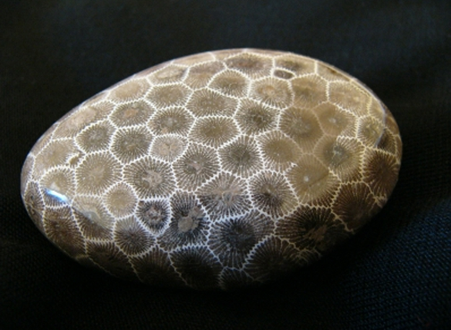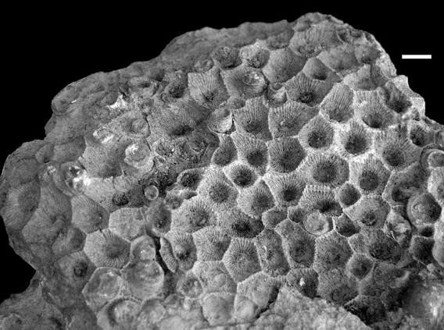

Resources for these activities

Mammoth molar. Oblique view showing top (chewing surface, about 7.5 inches or 19 cm long and 3 inches or 8 cm wide) and the “side” (root). The molar is about 10 inches or 25 cm from bottom to the root to the top. Permission for reproduction is granted for non-commercial, educational use. Please credit photographer Danita Brandt.
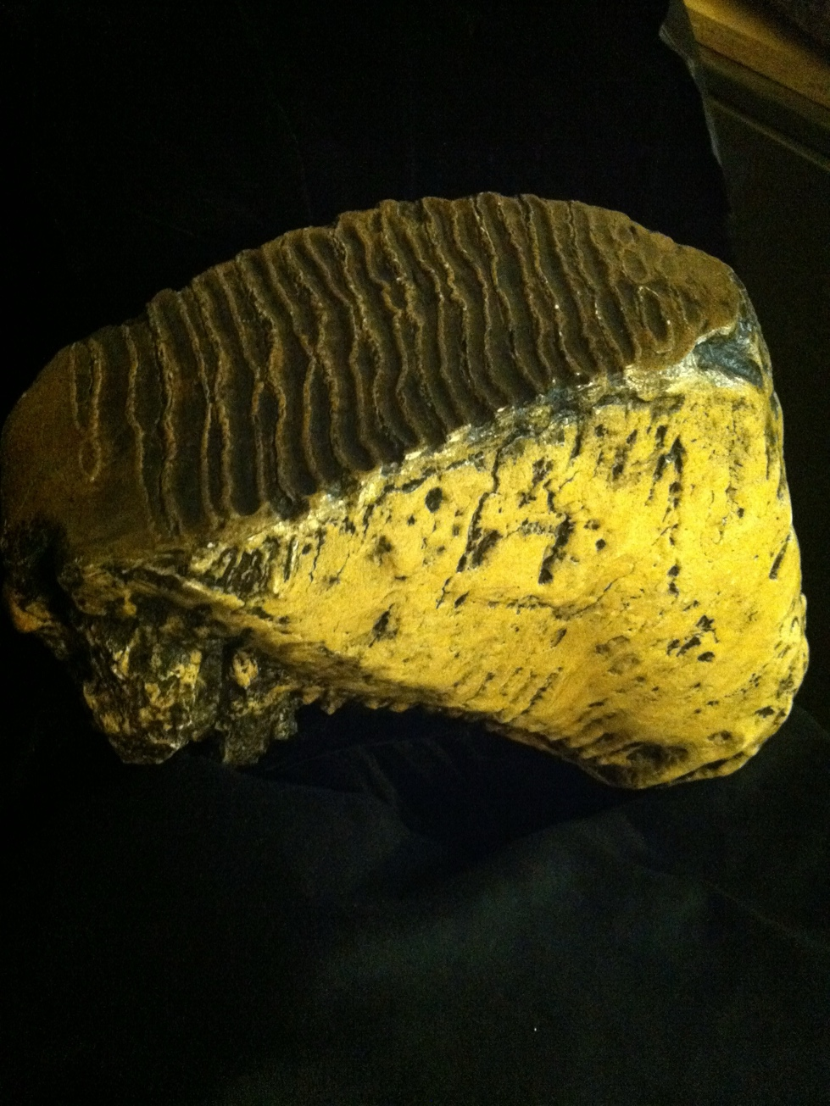

Mammoth molar- showing top (chewing surface)
Permission for reproduction is granted for non-commercial, educational use. Please credit photographer Danita Brandt.

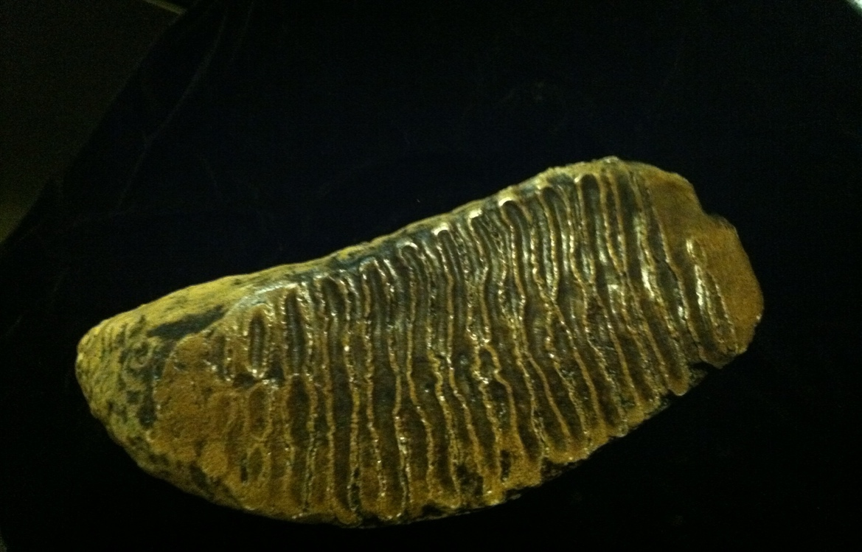

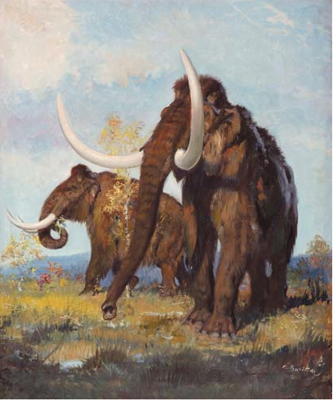
Mammoth in its grassland habitat
http://carnivoraforum.com/topic/9331102/1/
Mastodon molar

Mastodon molar side view showing top (chewing surface) and the “side” (root). The molar is about 6.5 inches or about 16 cm from bottom of the root to the top of the tallest cusp (‘bump’). Permission for reproduction is granted for non-commercial, educational use. Please credit photographer Danita Brandt.

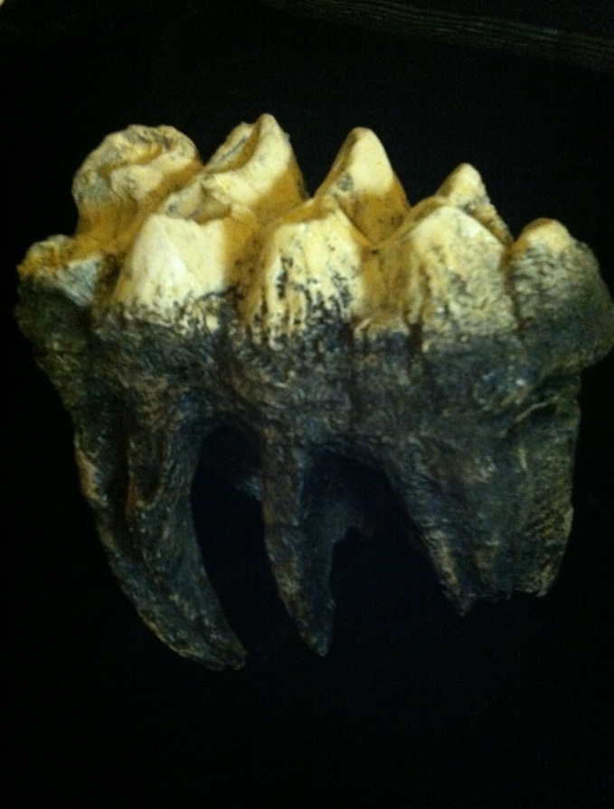

Mastodon in its woodland habitat. From the Illinois State Museum website.

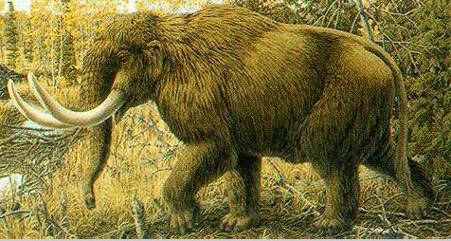

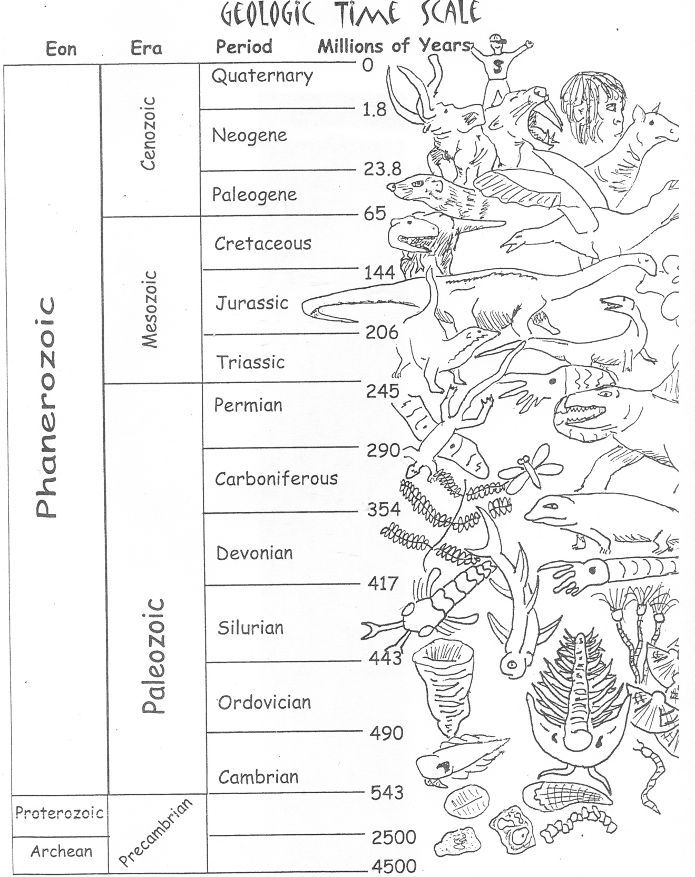

Drawing by Lisa Whitenack. Permission for reproduction is granted for non-commercial, educational use. Please credit the artist.

Materials List

Activity/Items | Supplier/Information
What is a fossil?
A rock (granite is good) | Rocks, minerals, and fossils: Contact local rock and mineral clubs for help in obtaining free or low-cost Michigan fossil kits. An online directory is available at https://www.geology365.com/club-directory/state/Michigan
A mineral crystal
Chicken feather
Fossil leaf
Arrowhead
Footprint imprint
Bone
Fossilized bone
Modern sea-shell
“Ocean in a jar” demo
Clear plastic jar w/lid
Two clam shells
Sand
Plastic fork
Fossil molds (imprints)
Air-drying clay | Hobby/craft store
Assorted shells
Small paper plate
Fossil cast activity
Plaster of Paris | Hobby/craft store
Container for water
Spoon or spatula
Mixing bowl for plaster
Cooking spray
Insects in Amber
Photos of amber fossils | Start with Wikipedia entry on “Amber”
What they ate
Mammoth molar cast or photo | Boneclones.com have high-quality resin casts
Mastodon molar cast or photo | Boneclones.com have high-quality resin casts
Image of mammoths grazing | http://carnivoraforum.com/topic/9331102/1/
Image of mastodon habitat | https://exhibits.museum.state.il.us/exhibits/larson/mammut.html
Drawing paper, pencils
Petoskey stone/Ancient environments
Polished Petoskey stone
‘rough’ Petoskey stone | Local avocational clubs, Michigan rock shops

General Paleontology Resources

Websites
Friends of the University of Michigan Museum of Paleontology Specimen Database:
http://strata.geology.wisc.edu/mibasin/
Website with lots of photographs of fossils, many of which can be found in the Great Lakes region

iDigBio. A database for paleontology enthusiasts. https://www.idigbio.org/education

Paleontological Research Institute’s Digital Atlas of Ancient life. https://www.digitalatlasofancientlife.org/

The Paleontological Society. The largest professional society for paleontologists includes resources for students and educators and a page where you can ask for help in identifying your fossil. https://www.paleosoc.org

The Paleobiology Database. A professional data repository, there are some accessible functions for the non-professional. https://paleobiodb.org/#/resources

Royal Ontario Museum Image Database: http://images.rom.on.ca/public/

University of California Museum of Paleontology Online Exhibits:
http://www.ucmp.berkeley.edu/exhibits/index.php
Extensive website with many images and background information for every major fossil group; also has extensive K-12 educational resources, online activities, modules, etc.

Books (classics)
Aliki. 1990. Fossils Tell of Long Ago. HarperCollins Publishers, New York.

Eldredge, Niles, Gregory Eldredge, and Douglas Eldredge. 1989. The Fossil Factory: A Kid’s Guide to Digging Up Dinosaurs, Exploring Evolution, and Finding Fossils. Roberts Rinehart, Lanham, MD.

Katz Cooper, Sharon. 2007. Learning from Fossils. Heinemann Library, Chicago.

Squire, Ann O. 2002. Fossils: A True Book. Children’s Press (Scholastic Inc.), New York.

Strain Trueit, Trudi. 2003. Fossils. Franklin Watts (Scholastic Inc.), New York.

Taylor, Paul D. 2004. Eyewitness Fossil. DK Publishing, Inc., New York.

