MLA YouPer (Young Person) Award

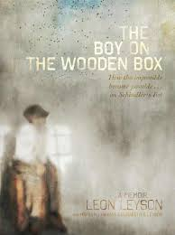
2014 YouPer Award
The Boy on The Wooden Box by Leon Leyson

Honor Books:
- Rump by Liesl Shurtliff
- Adventures of a South Pole Pig by Chris Kurtz
- The Great Trouble by Deborah Hopkinson
- Twerp by Mark Goldblatt

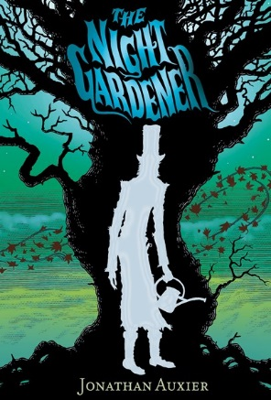
2015 YouPer Award
The Night Gardener by Jonathan Auxier

Honor Books:
- Boundless by Kenneth Oppel
- The Luck Uglies by Paul Durham

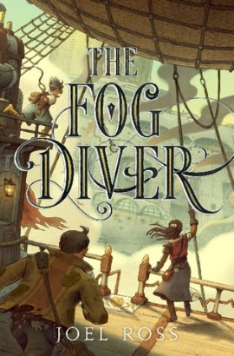
2016 YouPer Award
The Fog Diver by Joel Ross

Honor Books:
- Roller Girl by Victoria Jamieson
- The Underground Abductor by Nathan Hale

