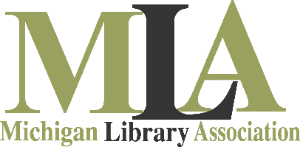

Education Fund Scholarship Application Information Sheet

Eligibility requirements:
To receive an MLA Education Fund scholarship to attend MLA workshops
and/or educational events:

- Applicant must be an individual member of MLA to qualify for an “Individual Member Scholarship,” and members are eligible to receive
one scholarship per lifetime.
- Organizational Members may apply for a scholarship on behalf of any
staff member, if that person is an Individual Member of MLA.
- Applicant must demonstrate financial need and effectively articulate
the value of the scholarship to their work.
- Deadlines for scholarship applications for any event/workshop/conference are listed below.

Instructions:
Scholarship applications are confidential.
- Complete the attached Education Fund Scholarship Application and submit by the deadline dates listed below.
- The Scholarship Awards Committee will review applications
shortly after the deadline.
- Applicants will be notified via email thereafter regarding the status
of their application.

Events | Deadline Dates
Annual Conference 2018 | September 1, 2018
Leadership Academy 2020 | TBD
Spring Institute 2019 | February 7, 2019
Workshops 2019 | February 7, 2019
Academic Libraries Conference 2019 | January 18, 2019

Please send this application via mail, email or fax to:

Mail:  Michigan Library Association  Attn: MLA Scholarships  3410 Belle Chase Way, Ste. 100  Lansing, MI 48911 | Email: rfitschen@milibraries.org  Fax: (517) 394-2675

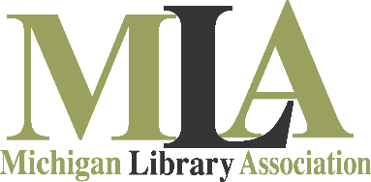

Education Fund Scholarship Application

Date of Application:

Applicant Information
Name:
Member number:
Library/Organization:
Mailing Address:
City/State/Zip:
Daytime Phone:
Fax:
Email Address:

Please list your volunteer service with Michigan Library Association (committees or workgroups):

Have you received a scholarship from the Michigan Library Association in the past?

If this application is for MLA’s Annual Conference, have you ever attended an Annual Conference before?

Will your employer, Friends Group or other community organization/group cover any of the cost of attending this program?

Amount of Employer financial support:

Event Information

Workshop/Event Name:
Workshop/Event Date:
Dollar Amount Requested:

Please address your current financial limitations or responsibilities, and other circumstances that you believe are pertinent to your meriting a scholarship (200 words maximum).

Please submit this scholarship application by mail, email or fax to:
By Mail:  Michigan Library Association  Attn: MLA Scholarships  3410 Belle Chase Way, Ste. 100  Lansing, MI 48911 | By Email:  rfitschen@milibraries.org | By Fax:  (517) 394-2675

