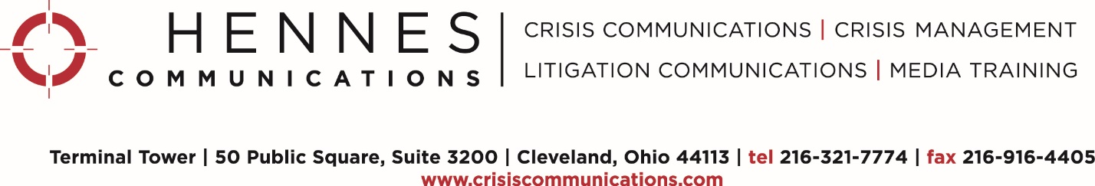

How to Interact with the Media

BEFORE THE INTERVIEW

- Remember that you are always on the record. Whether it’s an e-mail, a phone call, an interview, or a chance meeting with a reporter at a trade show, you are always on the record when you talk about your organization.

- Respect the reporter’s deadline. If you respond to a reporter’s inquiry, send a news release, media statement, etc. to a reporter moments before his/her deadline, you risk being marginalized in the story, or not mentioned at all. Whenever possible, get important materials to reporters well in advance of their deadline.

- Buy time. If you pick up the phone and a reporter begins to immediately ask questions, say you’d be glad to help him/her, but you’re in the middle of something and you’ll get back to them as soon as you can. That will give you time to meet with your communications team and prepare or, at the very least, think about your key messages.

- Interview the reporter. Whenever you’re on the phone with reporters, get their name and contact information. Ask if anyone else is being interviewed for the story and if they are sending a photographer. Put a limit of the amount of time for the interview – 15 minutes for TV interviews and 30 for print/web is generally acceptable for reporters.

- Research the reporter. Look at other stories the reporter has written/produced. What is his/her style? Aggressive? “Just-the-facts?” Friendly approach that escalates with tougher and tougher questions as the interview progresses? If any of your colleagues have been interviewed by the reporter, reach out to them to ask about their experiences.

- Send the reporter relevant materials in advance, time permitting, such as backgrounders, white papers, links or PDFs.

- Remember the audience. The reporter is NOT your audience. TV viewers, web/newspaper readers and radio listeners are the audience. Think about what those audiences want to hear from you.

- Develop key messages. They need to be short. Have no more than three or four messages – people cannot process a pile of information. When you say your messages aloud, they should sound like a TV soundbite, even with print or web reporters.

- Rehearse your messages aloud, stick to them throughout the interview, and bridge to them often when answering reporters’ questions.

- Be certain you prioritize your messages. Which is the one message you absolutely must get out in the interview? Focus on that message so that, if you remember nothing else during the interview, you will remember to insert your priority message.

- Do an interview dry run. Write down all the tough questions you’re anticipating, and a brief answer for each one. Include your messages in your answers whenever possible. Before the interview, time permitting, ask a colleague or friend to run through the questions so you can rehearse your answers and practice bridging to messages.

- Work closely with your public relations/communications department. They will help you with all of the aforementioned preparation and give you a final update on the situation before the interview begins.

DURING THE INTERVIEW

- Prepare a written statement and read it aloud to avoid being misquoted, particularly for controversial issues. If you need a written statement, be sure it is cleared by your corporate communications team and/or legal counsel, in the case of a controversial or potentially litigious issue.

- Set context with messages. Don’t wait for the reporter to start asking questions. Jump right in as the interview begins with a bridging phrase and a message, such as “…before we get started, let me tell you what’s most important for your audience (readers, etc.) to know.” Then insert your priority message. Chances are that by setting context, the reporter’s follow-up question will be based on your message.

- Stop speaking after you’ve said what you have to say. If the reporter is silent or jotting down notes after you’ve answered, resist the temptation to fill the silence. It almost always leads down unproductive paths. Reporters will not include your silence in their stories.

- Pause and think before answering. If a reporter is peppering you with rapid-fire questions, it’s OK to say “...let me think about that for a second to give you the best answer I can.” Take a few seconds to think about the message you need to deliver, and then deliver it. Again, unless you are silent for an egregious amount of time, reporters are not interested in using your silence in their stories.

- Repeat your messages often. Don’t worry about repeating them – remember, the reporter is only going to choose one or two soundbites or a few quotes. Repeating your messages increases the likelihood that the reporter will include them in his/her story.

- Use examples and/or anecdotes. Examples help bring messages to life. If, for example, your organization is improving internal policies and procedures, what are the steps being taken to do that? Are there success stories you can point to? Can you point to specific research that supports your messages?

- Speak only on behalf of your organization. Don’t guess how others are reacting to your situation. Simply say, “I can’t speak for another organization, but what I can say is…” and insert one of your messages.

- If the reporter asks a multi-part question or a series of questions, simply pick the one you are most comfortable answering and answer only that. If the other questions are that important to the reporter s/he will ask them again.

- If the reporter interrupts your answers, simply say “… I’ll be glad to answer that question, but I wasn’t finished answering your last question.” Then repeat and complete the answer you were giving.

- If you mess up, stop and repeat your answer. Reporters want to file a good story, and they want good soundbites or quotes from you. If you falter, stop and say “…let me give you that answer again.”

- Don’t speculate. Don’t bluff. If you don’t know an answer, tell the reporter it’s not your area of expertise, but that you’d be glad to find someone who can answer his/her question. Be sure to get that information to the reporter well in advance of his/her deadline.

- Don’t repeat negative language. If you repeat a negative statement and it is used out of context, you undermine your messages. Instead, politely disagree, saying “…that’s not right, and here’s why…” and bridge back to a message.

- Avoid using jargon and acronyms. The media audience will not understand terms that are “inside baseball.” Ask yourself if your grandmother would understand the answer you want to give. If not, simplify.

- Additional points to remember about reporters:
  - Reporters may start out friendly and straightforward, and suddenly shift to probing and hostile.
  - Reporters may state a distortion as fact to get a reaction from you.
  - Reporters may fire questions at you rapidly.
  - Reporters may demand answers to questions you cannot answer.
  - Reporters may ask for your personal opinion (and it’s OK to decline).
  - Reporters may falsely claim not to understand your answer.
  - Reporters may feign anger or friendliness, just to get you to talk.

AFTER THE INTERVIEW

- Send the reporter pertinent supplemental information. Fact sheets, media statements, FAQ, bios, web links – whatever you need to get to reporters to give them all the information they need to tell your side of the story should be sent in the body of an email, as e-mail attachments or web hyperlinks as soon as possible after the interview, and well before the reporter’s deadline.

Reporters will frequently cut-and-paste information directly from these handout materials into their stories, helping to better represent your side of the story. Print media will sometimes post these materials on their websites.

- If you learn of new information, share it. If new developments come up after the reporter has left, get them updated information as appropriate.

- Monitor coverage including web comments from readers and social media posts. Respond quickly to factual errors – but pick your battles. If the story is mostly accurate and favorable, consider whether it’s necessary or helpful to correct a minor error.

- Thank the reporter and copy his/her producer or editor if the story was accurate and fair. They will appreciate this, and it will increase your chances of being contacted for a future story.

###

Communication Model for Media Interviews

We are traditionally taught to communicate much as a pyramid is constructed (see diagram below). We are conditioned to begin answering questions with broad context such as historical data, timelines, factors contributing to the current situation, and so on. Ultimately, we build toward a response and present the message as our conclusion:

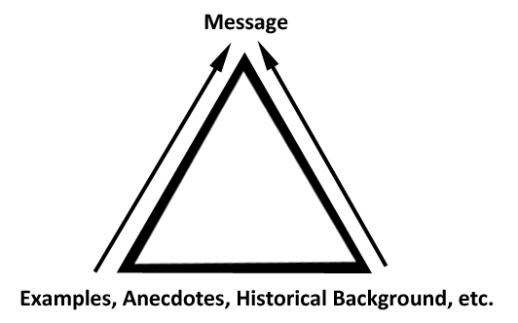

If reporters have to hunt through historical context first, they may miss your message entirely. In a media interview, you need to flip this communication model on its head. Begin by delivering a message. Then broaden your response to include examples, anecdotes, etc. to illustrate your message, much like the communication model below:

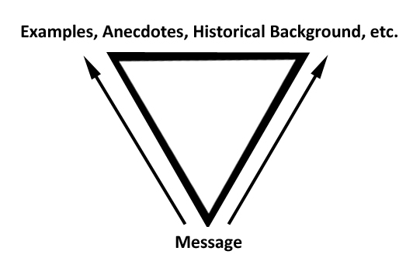

When you communicate with your message first, you increase the chances that a reporter will use your message as a soundbite or quote in his/her story.

Control Tool Prep Steps

When you are faced with a crisis or an issue in which you know you will be interviewed by the media, questioned by colleagues, customers, community leaders etc., taking the time to work through these steps will help supercharge your responses and give you better control over the direction of an interview, Q&A or conversation.

- MESSAGES
Have no more than three strong messages. Messages are not facts – they are broad statements about values, beliefs and actions that will resonate with your audience because they are TRUE. They should be constructed as conversational sound bites or pull-quotes, avoiding insider terminology and jargon. And the reason we suggest only three messages is that you will likely not be able to remember more than three in front of a camera. Prioritize your messages and use them often in a Q&A or interview. If nothing else, be certain the #1 priority message is delivered, and delivered frequently. Messages set context, and follow-up questions are often based on the context you set, giving you more control over the direction of the interview.

- QUESTIONS
Put yourself in the reporter's shoes. Or the audience at your public presentation. What would they ask you? Brainstorm and list as many questions as you can, making certain to write down the ugliest and most impertinent questions you might get. Better to be prepared in case you get them!

- ANSWERS
Now that you have enumerated anticipated questions, how would you answer them if they were asked? DO give answers – do not obfuscate or try to “spin” your way out of answering. That will come back to haunt you over and over again. If you can’t answer a question, say why – because of privacy concerns, proprietary information, etc. And if you do not know the answer to a question, say that, but add that you will either get back with an answer or suggest someone who CAN answer the question. Ask the reporter’s deadline and be certain to get back to him/her well in advance of that deadline, or risk being tossed off as a minor footnote in their coverage.

- BRIDGING
Now that you’ve answered the question, how can you bridge or transition back to a key message? Use key phrases: “...the important thing today is [insert message].” “...the key point to remember is [insert message].” If you can bridge back to a message, you are further controlling the flow of an interview. Be sure to hang on to the pocket-sized Hennes Communications tri-fold handout, which has a list of bridging phrases you can practice and use.

- EXAMPLES
Messages can sound like sloganeering without short examples. It is examples that bring messages to life. To illustrate: if your organization is committed to providing the safest environment for staff that it can, how are you doing that exactly? Be prepared to provide concrete examples demonstrating that your messages are not just hollow platitudes.

###

